**Lab H**

**Procedure:** Paper Chromatography

**Materials:**

* 50mL graduated Cylinder
* Hooked Stopper Cap
* Chromatography Paper
* Chromatography Solvent (rubbing alcohol)
* 10 mL Graduated Cylinder
* Ruler
* Wax Pencil
* Paper Towel
* Beaker or Cup
* Fresh leaf

In this lab you will need to collect a fresh leaf. You want to try and pick leaves that are “softer” rather than waxy. As an example, you could use a spinach leaf from the grocery store or a green leaf from a honeysuckle vine etc.

1. Using the cap with attached hook, hang a piece of chromatography paper to it and test the fit of the paper, you want the pointed tip to just barely touch the bottom of the tube.
2. Once you have the proper fit, remove the stopper cap and chromatography paper and, using your wax pencil, draw a faint line across the strip, about 2 cm from the tip of the strip. Place the stopper with the attached strip of chromatography paper into the top of the test tube and mark the test tube about 1 cm below the bottom of the cork.
3. Remove the strip of chromatography paper from the test tube and lay it on a flat surface. Take a fresh leaf and place it over the faint line you drew near the tip of the chromatography paper. Using a penny, or the tip of one of the wooden stir sticks in your kit, trace over the leaf onto the line. Repeat this a few times. You should see that some of the leaf pigment is now on the chromatography paper.

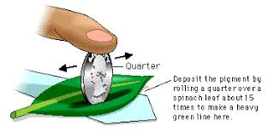

1. Use a 10 mL graduated cylinder to add ~5 mL of solvent (rubbing alcohol) to the test tube. Place the stopper cap with the chromatography paper securely hooked back onto the test tube. Be careful not to dip the pigment line into the solvent.
2. Keep the test tube securely capped and upright using a cup or your 100 mL beaker. Record your observations as the solvent moves up the paper. Your set up should look like the image below:

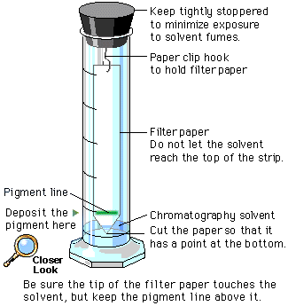

1. When the solvent has moved up to the line drawn near the stopper cap, remove the strip and let it dry. Identify the pigment bands using the chart below.
2. Measure the distance of the solvent from its origin to the highest point traveled on the paper. Then measure the distance the different pigments travel from the origin (pigment line near the tip) to the center of each pigment band. Record your measurements in the table below. Calculate the Rf (rate of migration) for each pigment.

|  |  |  |  |
| --- | --- | --- | --- |
| **Color of Band** | **Pigment** | **Migration (mm)** | **Rf Value** |
|  |  |  |  |
|  |  |  |  |
|  |  |  |  |
|  |  |  |  |
|  |  |  |  |
|  |  |  |  |

**Procedure 2: Yeast Fermentation**

**Materials:**

* Flask
* Balloon
* Rubber Band
* Sugar
* Yeast
* Warm Water
* Measuring Tape

1. Stretch out the balloon by blowing it up repeatedly, and then lay it aside.

2. Warm up about 200mL of water and mix in the vial of yeast and the vial of sugar.

3. You’ll notice the water bubbling as the yeast produces carbon dioxide. Attach the balloon to the mouth of the bottle and set both aside.

4. Using your measuring tape, measure the initial diameter of the balloon.

5. After several minutes, you’ll notice the balloon standing upright. If you don’t see anything happen, keep waiting. Observe the balloon for 30 minutes, measuring the diameter every 10 minutes. Record your observations below. You should also use your phone or camera and take a picture at these intervals.

|  |  |
| --- | --- |
| **Initial diameter of the balloon** |  |
| **Diameter after 10 minutes** |  |
| **Diameter after 20 minutes** |  |
| **Diameter after 30 minutes** |  |

6. After the 30 minutes has passed, remove the balloon and smell near the top of the flask to smell the contents. Describe the smell:

_____________________________________________________________________

7. In the lab, we would take a sample of this mixture and make a slide to observe under the microscope. If you happen to have a microscope give it a try! Because most people don’t usually have one handy, check out this short video and observe the yeast:

<https://www.youtube.com/watch?v=hJyFGYPyHbY>